

**MBA SCMS**

**III Semester MBA – Nov 2022**

**Course Title: Data Visualization for Decision Making**  **Course Code:** 20MBAB003

**Duration**: 90 Minutes **Date:**

**Time:**  **Max Marks:** 50

**Section – A**

**Short Answer - Answer any 2 Questions out of 3 (2 x 5 = 10)**

1. Explain the use of drill down view in Tableau.
2. Explain following terms: a) Data Source Page b) Dimension c) Calculated Field d) Dashboard e) Marks Card
3. Discuss the data types supported in Tableau

**Section – B**

**Answer any 2 Questions out of 3 (2 x 10 = 20)**

1. When does on need to use join feature? Discuss left, right and inner join with illustration.
2. Which visualization(s) is/are ideal for:
   1. Single Numeric variable
   2. Single Numeric variable when we wish to assess if the distribution is normal
   3. Single Numeric variables when we wish to detect outliers
   4. Single Categorical variable when there are 3-4 categories
   5. Single Categorical variable when there are 5 and more categories
   6. Two numeric variables
   7. Two categorical variables
3. Discuss the design flow in Tableau visualization

**Section – C**

**Case Study: 2 Questions Compulsory (2 x 10 = 20)**

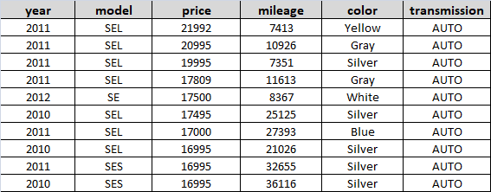

1. Identify measures and dimensions in above dataset.
2. Discuss useful summarizations and visualizations using above dataset